MOHAMMED SUFAID M

19CS078

SMART WASTE MANAGEMENT

SYSTEM FOR

METROPOLITAN CITIES

ASSIGNMENT - 1

1. **Schematic Diagram**

**Assignments -1 , Make a Smart Home in Tinkercad, using 2+ sensors, Led, Buzzer in single code and circuit.**

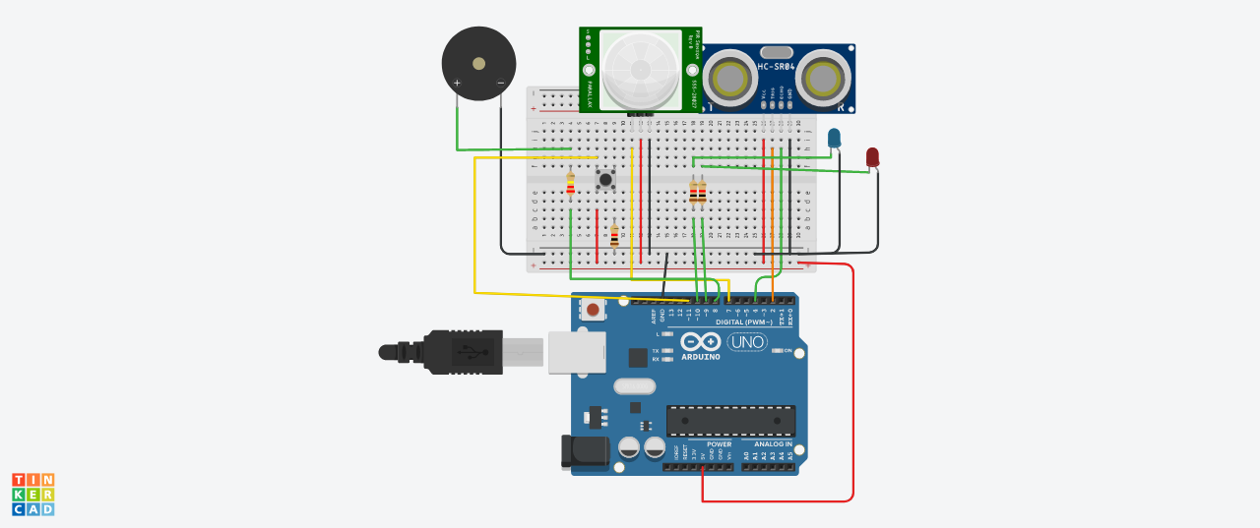

**Copy of Temperature, Motion Monitoring System**

**with a Piezo Buzzer**

1. **COMPONENTS USED :**

|  |
| --- |
| **COMPONENTS LISTS** |
| Push Button - 1 Qty |
| Red LED- 1 Qty |
| Blue LED- 1 Qty |
| PIEZO Buzzer- 1 Qty |
| Ultrasonic Distance Sensor- 1 Qty |
| PIR Sensor- 1 Qty |
| Resistor (220,560,10K)- 1 Qty |
| Arduino R3- 1 Qty |
| Breadboard Small- 1 Qty |

1. **CODE**

int baselineTemP = 0;

int celsius = 0;

int fahrenheit = 0;

int pinSensor =4;

int pinBuzzer =7;

int pirSensor =0;

void setup()

{

pinMode(A0, INPUT);

Serial.begin(9600);

pinMode(pinSensor, INPUT);

pinMode(pinBuzzer, OUTPUT);

pinMode(7, OUTPUT);

}

void loop()

{

baselineTemp = 60;

pirSensor = digitalRead(pinSensor);

celsius = map(((analogRead(A0) - 20) * 3.04), 0, 1023, -40, 125);

fahrenheit = ((celsius * 9) / 5 + 32);

Serial.print(celsius);

Serial.print(" C, ");

Serial.print(fahrenheit);

Serial.println(" F");

if (celsius >= baselineTemp + 1) {

tone(7, 220, 100);

delay(100);

}

if (pirSensor == HIGH)

{

tone(pinBuzzer, 1000, 500);

}

delay(100);

}